Inverted Pendulum Aerofoil in a Flow-field

Yogi Patel,*Dr Scott Dawson, Sai Simon
MMAE Department, Illinois Institute of Technology, Chicago, IL, 60616
ypatel24@hawk.iit.edu
sdawson5@iit.edu

Abstract - This project explores the dynamics of an unstable system which is a fluid dynamic equivalent to an inverted pendulum. We consider an aerofoil that can freely pitch about its trailing edge. The system was modelled using Theodorsen’s theory of unsteady aerodynamics. A controller is designed based on this model, which allows for the unstable system to be stabilized through heaving motion at the trailing edge. These controllers are tested on high fidelity numerical simulations to validate the viability of this approach. The feedback control was combined with an open-loop strategy to achieve a ${180}^{∘}$swing-up and stabilization manoeuvre. Along with stabilizing the system, we additionally explore extracting energy from the flow, where we find that simple low-frequency input strategies can extract energy that is twice than the input energy.

I. INTRODUCTION

An unsteady system like inverted pendulum provides us with an opportunity to study the system by incorporating aspects of fluid mechanics, dynamics and control theory. For the standard inverted pendulum, there have been many experimental as well as computational studies performed to stabilize the system. The fluid dynamic equivalent to an inverted pendulum, the system of interest in this paper, is an aerofoil pitching around its trailing edge in a uniform flow field. In the inverted pendulum assembly, the pendulum tends to move in a way that the centre of gravity lies below the pin joint support. Keeping this setup into consideration, this paper focuses on designing and implementing control strategies for both an idealized system, and a viscous Navier-Stokes direct numerical simulation.

McGilvray¹ discusses the open-loop swing up manoeuvre by swinging the pendulum at its natural frequency and separate closed-loop control for stabilization. The system and controller model of interest will be subjected to the swing up manoeuvre suggested by McGilvray to get a better understanding of the system dynamics. The distinctive part of this project from several others is that here the system is controlled despite having a constant flow field.

System Configuration

To have a physical interpretation of the system, the schematic of the pitching base aerofoil is shown in Figure 1. The aerofoil is pivoted onto a cart which can oscillate in the x-axis. The flow with velocity U is flowing from top to the bottom direction.

When the system is placed in a flow regime it can become unstable when a small disturbance acts on its surface.

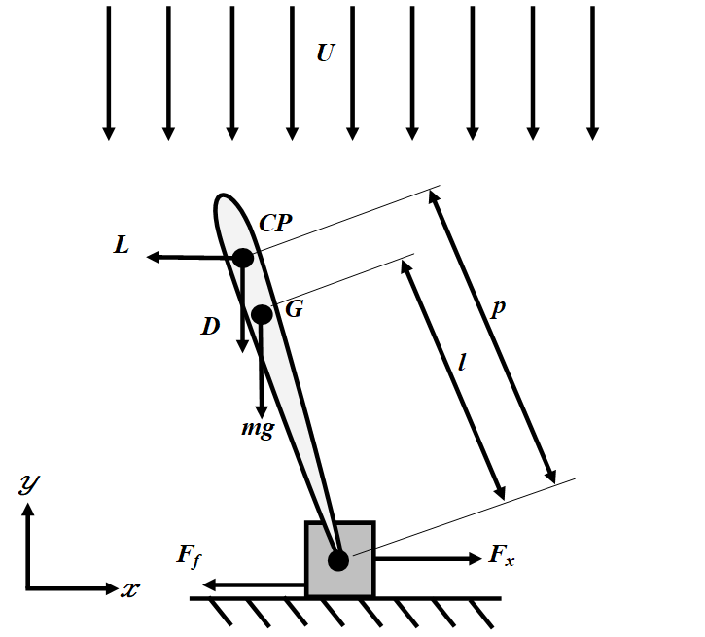

Figure 1: Pitching Base Aerofoil

To balance the pitching base aerofoil a permanent controller is placed at the trailing edge which oscillates in the counter direction of disturbance and makes the system stable. For this system, the control input is the acceleration provided at the trailing edge of a pendulum and the outputs are the angular position, angular acceleration, and the velocity of the pendulum.

Consider the free body diagram of the aerofoil, the governing equations for the system are derived as below:

$$\left(M+m\right)\frac{d^{2}y}{dt^{2}}=L+F_{v}-γ\frac{dy}{dt}-\left(M+m\right)g -ml\left[\frac{d^{2}α}{dt^{2}}cosα-{\left(\frac{dα}{dt}\right)}^{2}sinα\right]$$

And from the moment applied on an aerofoil and its angular acceleration the relationship is derived as below:

$\left(I_{G}+ml^{2}\right)\frac{d^{2}α}{dt^{2}} +mlcosα\frac{d^{2}y}{dt^{2}}-mglsinα$
$-\left(Lcosα\right)p=0$
where,
M = mass of the pin support block
m = mass of the airfoil
y = position of pin support in the x direction
L = lift on the airfoil acting at the aerodynamic center
$F_{v}$ = vertical force acting on the pin support block
$M_{l}$ = moment due to lift
$γ$ = frictional coefficient between the pin support block and the vertical wall
g = acceleration due to gravity
l = distance between the pin support and the centre of mass
$α$ = angle between the centre line of the airfoil and the y axis
$I_{G}$ = moment of inertia of the airfoil around its centre of mass
D = drag on the airfoil acting at the aerodynamic center
p = distance between the pin support and the aerodynamic centre

Note that the governing equations here include the aerodynamic forces like lift and drag force. Considering this physical significance of the system, the following important assumptions will be made:

- Airfoil shape is not negligible due to aerodynamic forces being the major driving factor of the system response.
- The drag force is neglected for small-angle assumptions.
- Gravity is neglected for simplicity.

Studying the system using Theodorsen Lift Model

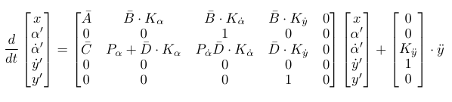
Theodorsen's lift model² is an analogous approach to thin aerofoil theory but it involves the method of conformal transformation where the physical domain (aerofoil shape) is transformed into a computational domain (circle) using one-to-one mapping. Theodorsen's lift model helps to study the pitching and plunging aerofoil. That's why using this model rather than the traditional thin aerofoil model will provide better system outputs. Here considering the circulatory and non-circulatory lift and moment equations help us to incorporate the physical aspect such as heave acceleration (which in the current system is trailing edge's acceleration).

From Theodorsen's theory², the moment around the pitching point on the airfoil produced by the lift is
$$M_{e}=ρπ\frac{c^{2}}{4}\left(\frac{c}{2}\right)\left(\overset{··}{y}-\left(\frac{c}{2}\right)\overset{··}{α}\right)-\frac{ρπ\frac{c^{4}}{16}}{8}\overset{··}{α}$$

$-ρπ\frac{c^{2}}{4}\left(\frac{-c}{4}\right)\overset{·}{α}+πρUec^{2}C\left(Uα+\overset{·}{y}+\left(\frac{-c}{4}\right)\overset{·}{α}\right)$

and the lift acting on the airfoil is

$$L=ρπ\frac{c^{2}}{4}\left(\overset{··}{y}\left(\frac{c}{2}\right)\overset{··}{α}+U\overset{·}{α}\right)+UρπcC\left(Uα+\overset{·}{y}+\left(\frac{-c}{4}\right)\overset{·}{α}\right)$$

where,
c = chord length of the airfoil
e.c = distance between the aerodynamic centre and the pitching point
C = Theodorsen's function

This moment and lift expression from the Theodorsen's model are substituted into moment balance equation and linearized using the small angles assumptions $α^{'}≪1,sinα^{'}≈α^{'},cosα^{'}≈1$ to get the state space representation:

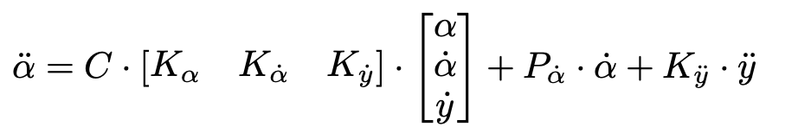

$K_{α}=\frac{ρπU^{2}ec^{2}+ρπU^{2}clcosα_{eq}-ρπU^{2}clα_{eq}sinα_{eq}}{D}$
$$K_{\overset{·}{α}}=\frac{-ρπUe\frac{c^{3}}{4}-ρπU\frac{c^{2}}{4}lcosα_{eq}}{D}$$
$$K_{\overset{·}{y}}=\frac{ρπUec^{2}+ρπUclcosα_{eq}}{D}$$
$$P_{\overset{·}{α}}=\frac{ρπ\frac{c^{3}}{16}+ρπU\frac{c^{2}}{4}lcosα_{eq}}{D}$$
$$K_{\overset{··}{y}}=\frac{ρπ\frac{c^{3}}{8}+ρπ\frac{c^{2}}{4}lcosα_{eq}-mlcosα_{eq}}{D}$$
where, D = $I_{G}+ρπ\frac{9c^{4}}{128}+ρπ\frac{c^{3}}{8}lcosα_{eq}+ml^{2}$ in all the terms.
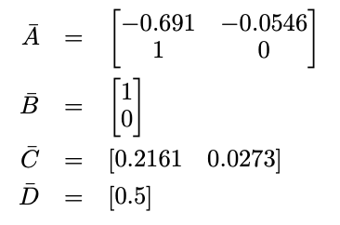
Theodorsen’s function was expressed as a state-space realization using R.T Jones approximation as stated by Brunton et al³. The state-space representation in matrix form:
where,

The system was stabilized by putting a feedback loop as shown in the figure below:
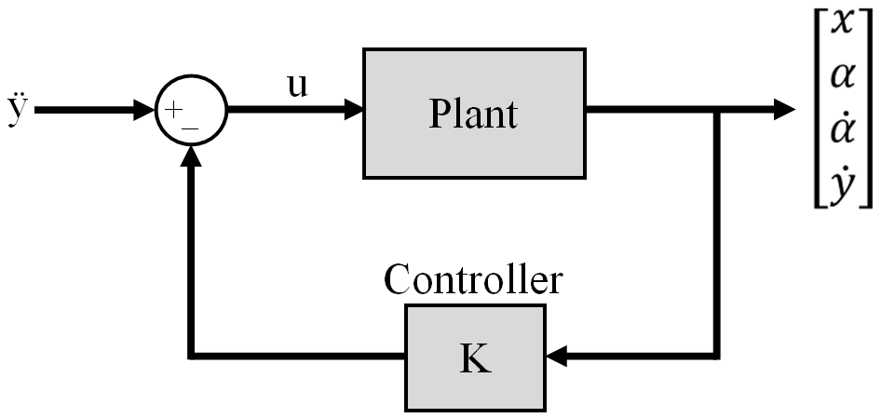

Figure 2: Feedback Control
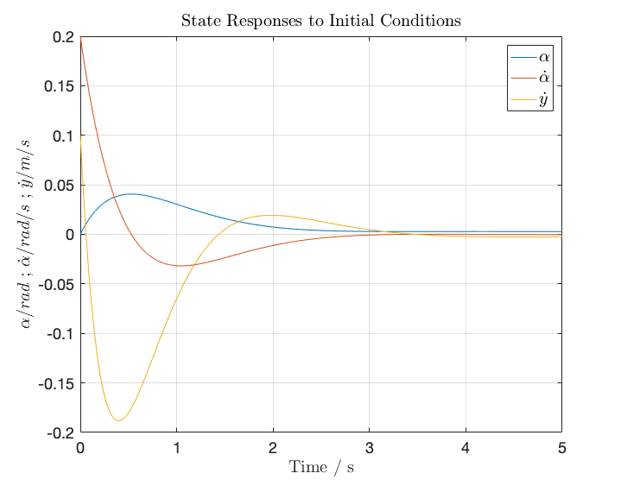
The vector of the state-feedback control gains (K) was found using the "lqr" command in MATLAB. The system response as per the initial condition of [0,0,0,0.2,0.1] is shown in the following figure.
Figure 3: Close-Loop Response
II. METHOD (Full Viscous DNS solver)

Here we extend our analysis to look at a full viscous direct numerical simulation (DNS). We use an immersed boundary projection method developed by Colonius & Taira⁵ to solve the 2-D incompressible Navier Stokes equation around a geometry similar to that of an inverted pendulum aerofoil. The system is a flat plate of a unit length, it is placed vertically in a flow field. The leading edge is free to oscillate while the trailing edge is pivoted with the surface.

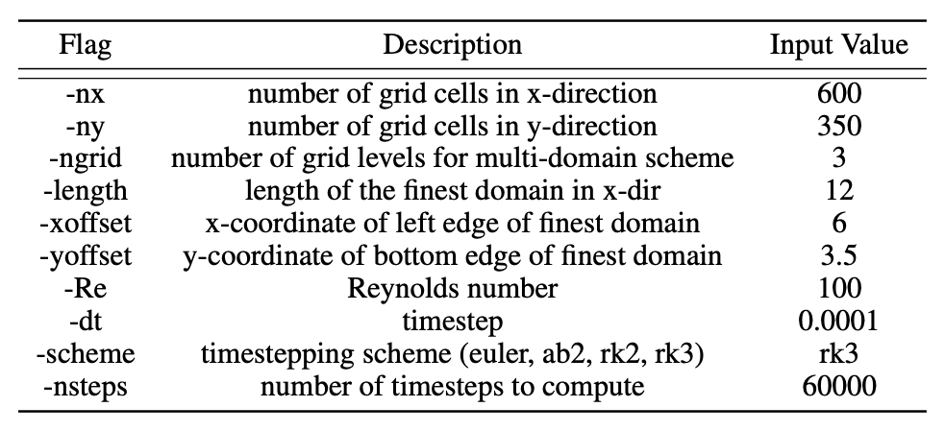
The command line tool "ibpm" reads the geometry file and the initial flow field and advances the flow forward in time, writing various output files. For the current study the grid parameters and other simulation variables are shown below:
In the current version of the code, the system states such as the angle of attack, angular velocity, the position of trailing edge and velocity of the trailing edge were controlled using a proportional feedback control strategy as shown in Figure 2. Here, the system identification was performed by taking a different set of input and output data to come across the governing gain values. The proportional gains outputted from system identification are 187.543, 82.5883, 18.436, 7.1546 for system states of $α,\overset{·}{α},y,\overset{·}{y}$ respectively.

This system has two different types of control strategies, the closed-loop control for stabilization and open-loop control for swing up manoeuvre.

The closed-loop control has the following inputs:

$\overset{··}{y}=K_{α}⋅α+K_{\overset{·}{α}}⋅\overset{·}{α}+K_{y}⋅y+K_{\overset{·}{y}}⋅\overset{·}{y}$

When the flat plate is kept vertical at $0^{∘}$AOA then due to small disturbances the leading edge will go towards ${180}^{∘}$AOA (i.e stable equilibrium) and will settle there. But while the leading edge is moving towards a stable equilibrium, if the trailing edge moves in the counter direction of the disturbance then it can neglect the disturbance effect. The closed-loop controller stabilizes the system up to around ${95}^{∘}$ AOA. (Note: $0^{∘}$ AOA refers to unstable equilibrium and ${180}^{∘}$ AOA refers to stable equilibrium)

Therefore, if there is disturbance higher than this value
(> 95 deg), then open-loop control strategy can be employed. In this strategy, the trailing edge of the flat plate will oscillate with a particular input. This input can be further classified into swing-up amplitude and swing-up frequency value as shown in the following equation. The swing-up manoeuvre brings the aerofoil close to unstable equilibrium. And, once the pendulum's leading edge is within the range of closed-loop control (i.e. $0^{∘}$ to ${95}^{∘}$ AOA), the closed loop controller will take over the control.
$\overset{··}{y}=Acos(f⋅t)$

where A is the swing-up amplitude and f is the swing-up frequency (rad/s)

The system has a separate control design for swing up and separate control design for the stabilization. The control function in swing-up manoeuvre namely natural frequency and gain value adjusts the amplitude of the sine wave function.

The flow induced vibrations were observed near the stable equilibrium, and the flat plate kept oscillating at a particular frequency without any input. Therefore, this frequency was assumed to be the natural frequency of the system. In further section more practical application of this particular frequency value in terms of getting net energy-out greater than net energy-in is mentioned.

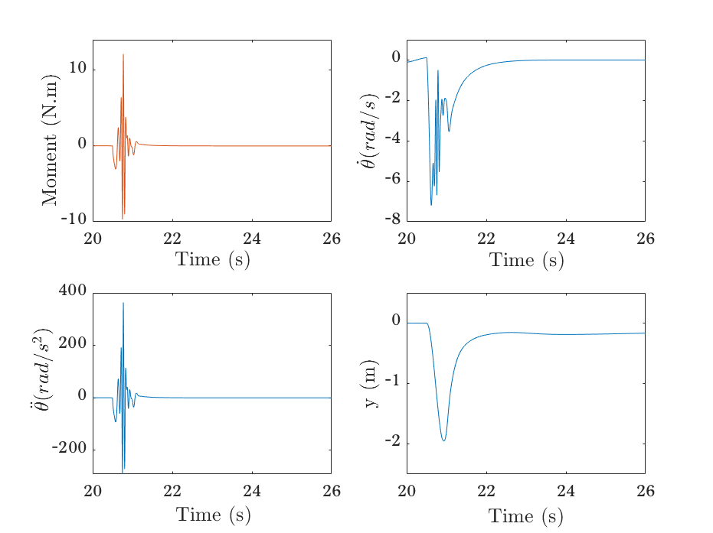
Following is the result of one of the simulations, where initially the flat plate was lying at ${180}^{∘}$ AOA. Its angle cannot be controlled by a closed-loop controller, so a swing-up manoeuvre is performed. Here the swing-up starts at 20.5 sec and at 20.86 sec the angle of attack (AOA) reaches ${95}^{∘}$. This value falls under the range of closed-loop controller therefore the close loop controller will take over the system control from 20.86 sec. And further, it will stabilize the system (means to reach $0^{∘}$ AOA). It can be noted from y(m) vs time(sec) subplot in Figure 4 that the trailing edge of the flat plate moves towards left (-ve direction) with a relatively high velocity of 7 m/s in a fraction of second. This makes the free of the flat plate (the leading edge) to swing upwards.
Figure 4: System states for Swing-up Amp: 1, Swing-up Freq: 7 rad/s

To further visualize the performance, 8 different data points are highlighted on the curve in Figure 5. Those 8 data points correspond to the outputted 8 different images from DNS simulation as shown in Figure 6.

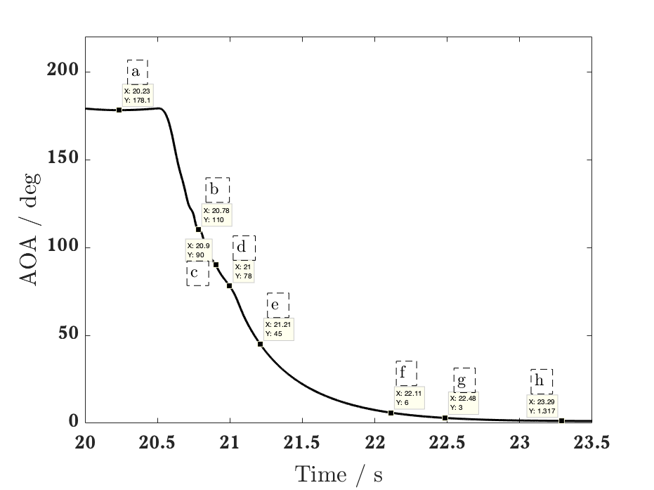
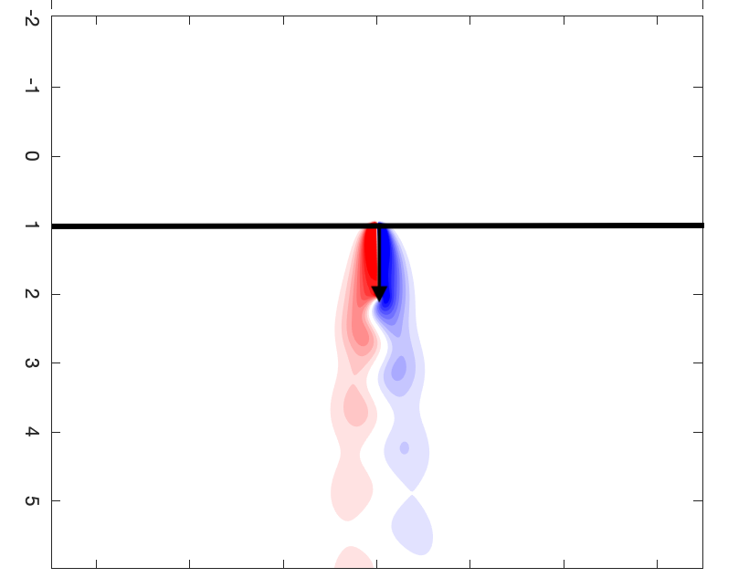
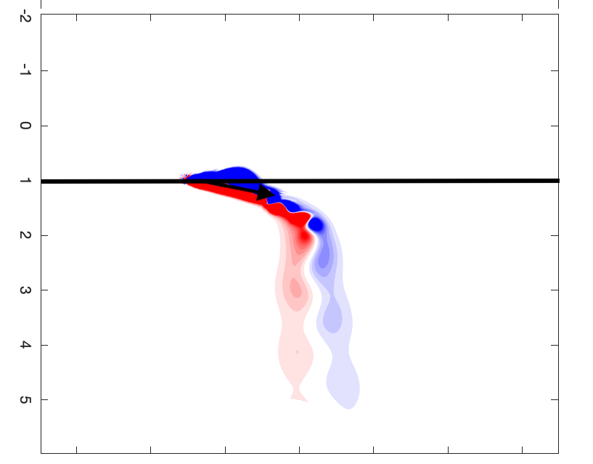
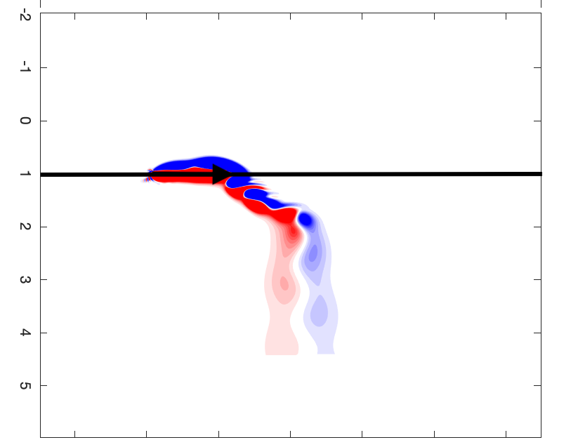
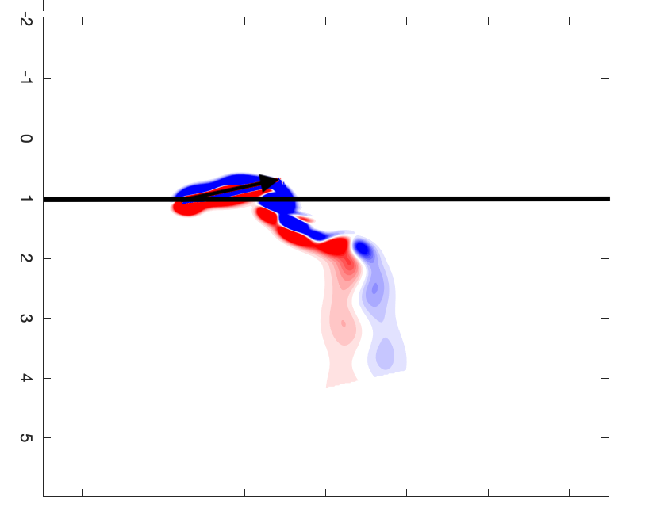
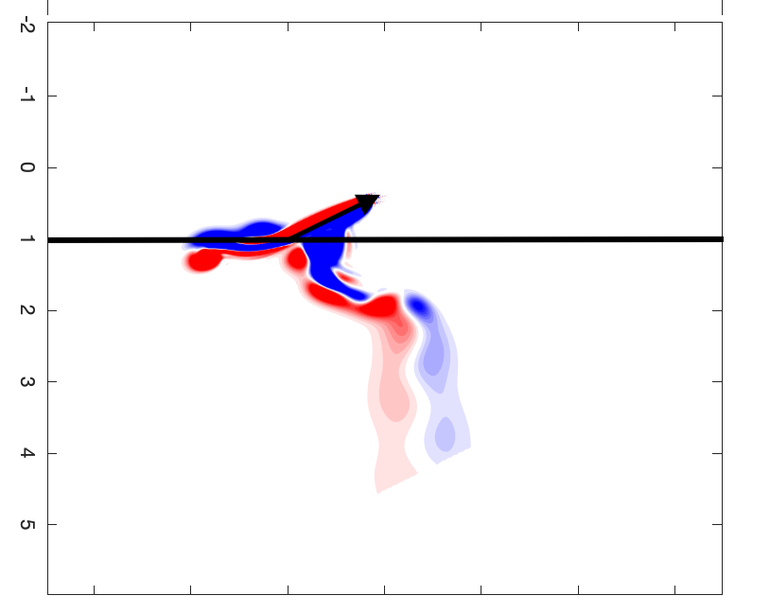
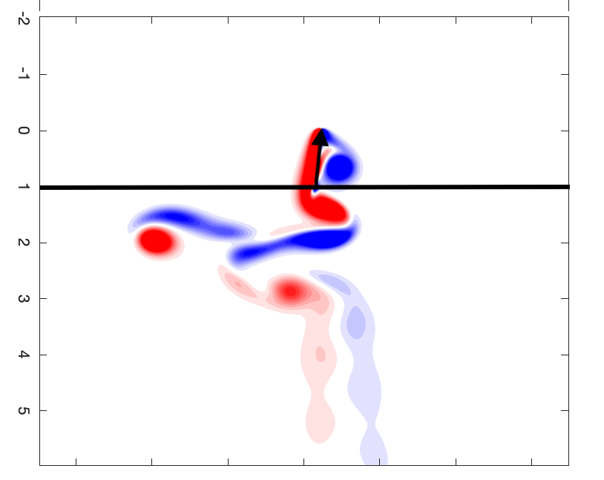
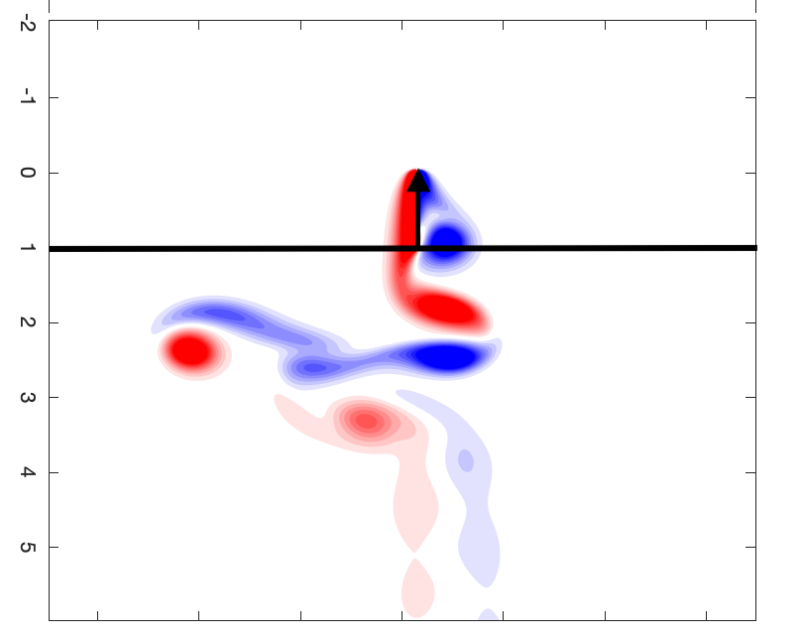
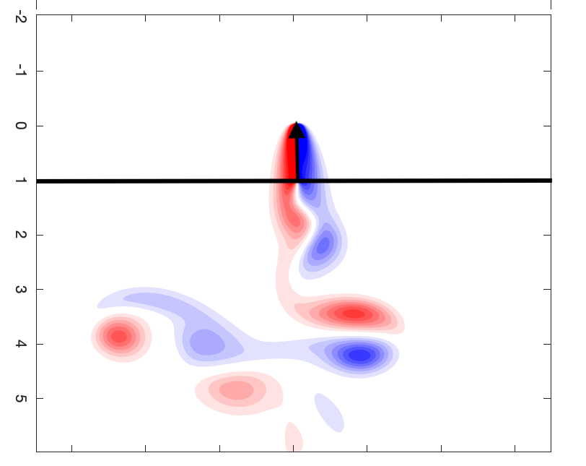
Figure 5 : Angle of Attack at various time-steps

[g]

[f]

[e]

[c]

[d]

[b]

[a]

[h]
Figure 6: Visualization of the system at various time-steps in the simulation

III. RESULTS

The swing-up manoeuvre mentioned in the previous section can be studied further and can potentially be applied towards extracting energy from the flow. Consider that the energy inputted to the system is sort of linear velocity given to the trailing edge of the pendulum, while the energy out is the angular velocity from the leading edge of the pendulum. If the net energy out is greater than energy in, then this system configuration can help us to produce more energy. The extra energy-out can be thought of as coming from the flow. Several simulations were run at the different rotational inertia values at different amplitude and frequency values in order to understand the correlation of one parameter to another. From those results, a definitive pattern was observed.

$E_{out}=τ⋅α$ $E_{in}=F_{y}⋅y$

where, $τ$ is the moment at the leading edge, $α$ is the angle of attack, $F_{y}$ is the force applied at the trailing edge, and y is the horizontal distance of the trailing edge.

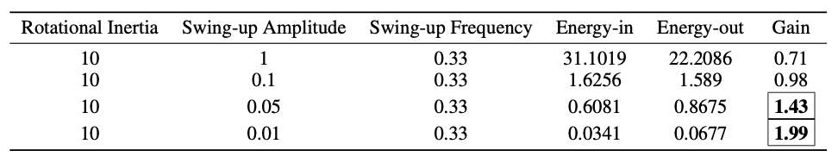
Following is the table to compare the same rotational inertia value and swing-up frequency. It can be noted that as swing-up amplitude is decreased the net gain $(E_{out}/E_{in})$ increases linearly. It can be seen that at relatively low amplitude, the net energy-out from the system can be twice as compared to energy-in.
IV. CONCLUSION

In this paper, the unsteady aerodynamic system of an inverted pendulum was studied. It also explores the further implementation of state-space realization for Theodorsen function using R.T Jones approximation. Then the closed loop controller was designed to stabilize the system, but it appeared that it could control a specific range of angle of attack. Therefore, to control the system at a higher angle of attack the open-loop swing up manoeuvre was implemented. This allowed for full control of airfoil position over all angles of attack. The significance of the two different parameters involved in open-loop control was studied. The swing-up manoeuvre was visualized in the images outputted from the DNS solver. It was noted that lowering down the swing-up amplitude produces more energy out as compared to the energy given to the system.
REFERENCES

[1] Stephen McGilvray, “Self-Erecting Inverted Pendulum: Swing Up and Stabilization Control,” IEEE Life Member Award for the 2002 IEEE Canada Student Paper Competition

[2] Theodore, Theodorsen. General Theory of Aerodynamic Instability and the Mechanism of Flutter, REPORT No. 496 - NASA. United States, 1 Jan.1949.

[3] Brunton and Rowley, Empirical state-space representations for Theodorsen's lift model, Journal of Fluids and Structures, 2013

[4] Jones, R. T., 1938. Operational Treatment of the Non-Uniform Lift Theory in Airplane Dynamics, NASA Technical Note

[5] Colonius, T. & Taira, K. 2008 A fast immersed boundary method using a nullspace approach and multi-domain far-field boundary conditions. Comput. Methods Appl. Mech. Eng. 197, 2131–2146.

