Using Microfluidic Devices to Model and Investigate Leaky Gut Syndrome
Jasmine Baste, Chengyao Wang, *Abhinav Bhushan
a: Biomedical Engineering, Illinois Institute of Technology, Chicago, IL, 60616
jbaste@hawk.iit.edu
abhushan@iit.edu
Abstract-Leaky Gut Syndrome develops when the permeability of the intestine increases allowing bacteria and toxins to leak into the bloodstream. Current methods used to investigate leaky gut are insufficient because they do not properly model the intestinal environment. Conversely, microfluidic devices are incredibly useful because the cells function better, the devices enable more efficient co-culture with other cells and bacteria, and only a small number of cells are required to obtain the results over traditional cultures. Preliminary experiments to create the leaky gut environment included culturing Caco-2 cells in two-chamber PDMS microfluidic devices until differentiation; gene expression was higher in the microfluidic devices than in the Transwell plate. In order to model the leaky gut, the cells were treated with alcohol and tested for epithelial integrity breakdown through permeability. The cells treated with the 5% alcohol had a significant increase in permeability, effectively modeling leaky gut ex vivo. Moving forward, different therapeutic molecules will be tested to determine whether the leaky gut can be restored to a normal state. The research done here can be applied to intestinal bowel disorders and other dysfunctions in the body to better the health field.

Introduction
When the intestine has increased permeability or Leaky Gut Syndrome, bacteria and toxins can leak through the intestine. Leaky gut is problematic because the gut is supposed to prevent bacteria, undigested food, and harmful chemicals from entering the blood¹. Unfortunately, leaky gut is a major problem in intestinal bowel disorders and other dysfunctions in the body. The purpose of these experiments is to mimic the environment of Leaky Gut Syndrome and test to see if the leaky gut can be reversed to make advances in health.

Method
To test the cell differentiation of gut cells in microfluidic devices: Caco-2 cells were cultured into microfluidic polydimethylsiloxane (PDMS) devices and Transwell plates and allowed to differentiate for three weeks. After 1, 2, and 3 weeks the plate samples were stained using tight junction antibody ZO-1 for imaging and were used for qPCR analysis.
To determine proper % alcohol in order to model leaky gut: Prior to building a leaky gut model, we first determined the alcohol concentration that causes the Caco-2 cells monolayer to break down and increase the permeability of lucifer yellow molecules from the apical chamber of 48-Transwell insert to the bottom chamber. According to previous studies³, 5% alcohol-treated cells for 60 min remained high viability of Caco-2 cells that were similar to the viability of the cells without treatment and caused the lowest transepithelial electrical resistance (TEER). According to this, we used different concentrations of alcohol: 0, 2.5, 5, 7.5, and 10 % to treat Caco-2 cells for 60 min. Then we tested the lucifer yellow transportation by adding 200 μL 5 mg/ml lucifer yellow in the top chamber, and 600 μL blank buffer in the bottom chamber, incubated for 60 min in the cell culture incubator. We collected the solution in the bottom chambers and measured the fluorescence of the collected solution using a plate reader. The fluorescence of blank buffer and 5 mg/ml lucifer yellow solution were measured as well. Then we used the numbers obtained from the plate reader to calculate the % of Relative Permeability using Equation 1³:

$Relative Permeability (\%) =\frac{Sample - Blank}{Lucifer Yellow - Blank}×100\% [Eq. 1]$

Here, Sample is the fluorescence reading of solutions collected from each well with different % alcohol treatment, Blank is the fluorescence reading of the blank buffer, and Lucifer Yellow is the fluorescence reading of 5 mg/ml lucifer yellow solution.
To test permeability on alcohol-treated cells in order to model leaky gut: Caco-2 cells were cultured into Transwell plates and allowed to differentiate for three weeks. At 1,2, and 3 weeks half of the samples were treated with a 5% ethyl alcohol for 1 hour and the Lucifer Yellow assay was performed to determine the integrity of the monolayer. This alcohol concentration was chosen from a previous study which found that 5% alcohol dilution was optimal to study epithelial cell degradation².

Results & Discussion
Over the three weeks, the tight junctions of the Caco-2 cells were clearly defined under the microscope (Figures 1a-c). Our test indicated that 5% alcohol and 60 min is the best concentration and treatment interval in modeling leaky gut, which caused a high permeability of lucifer yellow but maintained cell viability at a high level³(Figure 2). The permeability tests of control (Caco-2 cells cultured in 48-Transwell insert for 1,2 and 3 weeks without alcohol-treated) (Figure 3) supported these results of ZO-1 staining (Figure 1). The longer the cells were differentiated, the less permeable the cell monolayer was. The alcohol did induce the monolayer to be more permeable in the early differentiation stage (1 and 2 weeks) which is the result that was anticipated and needed to model leaky gut.
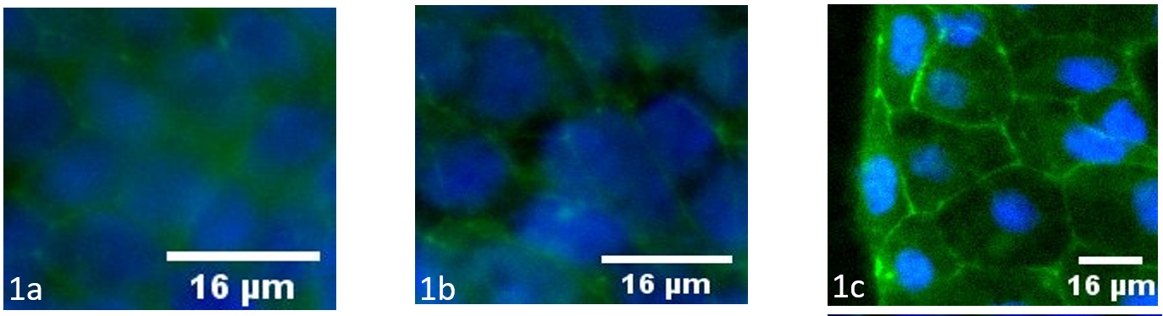Figures 1a-c: ZO-1 Immunostaining images of Caco-2 cells at 1, 2, and 3 weeks, respectively.
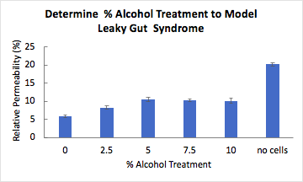
Figure 2: % Lucifer yellow passages from the apical chamber of 48-Transwell insert to bottom chamber. Caco-2 cells were cultured for 1 week.

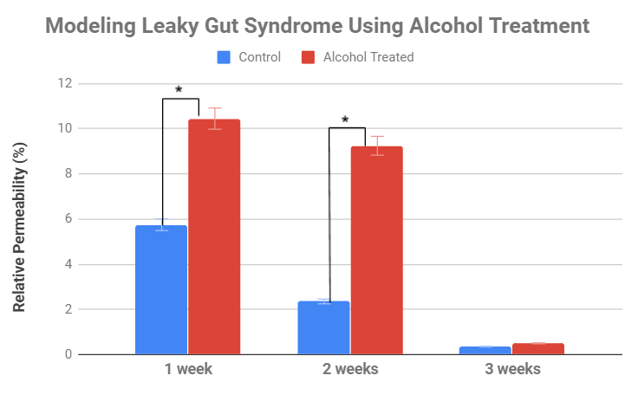
Figure 3: Monolayer permeability determined from transport of Lucifer Yellow after alcohol treatment of 60 minutes and without alcohol treatment over 1, 2, and 3 weeks. Data at 1 and 2 weeks were significant (p<0.05).

Conclusion
With this research, Leaky Gut was modeled by treating the cells with alcohol. Further alcohol cell exposure will be tested for longer periods of time and more frequently. Caco-2 cell differentiation over three weeks in microfluidic devices will also be tested. These preliminary experiments will allow for alcohol exposure testing on the cells in the microfluidic devices. Once these preliminary experiments are done, testing will be done with therapeutic molecules to treat or reverse permeability in the monolayer .

Acknowledgments
Thanks to the ACE Undergraduate Research Program for the support and funding to make this project possible.

References
[1] Liang, S., Wu, X., & Jin, F. (2018). Gut-Brain Psychology: Rethinking Psychology From the Microbiota–Gut–Brain Axis. Frontiers in Integrative Neuroscience, 12. https://doi.org/10.3389/fnint.2018.00033

[2] Mtox1002pc24bul.pdf. (n.d.). Retrieved June 18, 2020, from https://www.sigmaaldrich.com/content/dam/sigma-aldrich/docs/Sigma/Bulletin/1/mtox1002pc24bul.pdf

[3] Wang, Y., Tong, J., Chang, B., Wang, B., Zhang, D., & Wang, B. (2014). Effects of alcohol on intestinal epithelial barrier permeability and expression of tight junction‑associated proteins. Molecular Medicine Reports, 9(6), 2352–2356. https://doi.org/10.3892/mmr.2014.2126

