Alpha7 Nicotinic Acetylcholine Receptor Modulation of Descending Pain Control Pathways
Emma Hovanec,ª Shivang Sullere,^{b} and *Daniel McGehee ^{c}
ª The College, University of Chicago, Chicago, IL 60637
^{b} Grossman Institute for Neuroscience, Quantitative Biology, and Human Behavior, University of Chicago, Chicago, IL 60637
^{c} Department of Anesthesia and Critical Care, University of Chicago, Chicago, IL 60637
emmahovanec@uchicago.edu
dmcgehee@dacc.uchicago.edu

Abstract - The ventrolateral Periaqueductal Gray (vlPAG) is a midbrain structure in the descending pathway that modulates chronic and acute pain. vlPAG plays a critical role in pain transmission via projections to the Rostral Ventromedial Medulla (RVM), which projects to spinal cord. Existing research demonstrates that vlPAG neurons express α7-nicotinic acetylcholine receptors (α7-nAChRs), and activation of these receptors produces anti-nociception with efficacy similar to opioids. Recent studies show that chemogenetic excitation of glutamatergic neurons or inhibition of GABAergic neurons in vlPAG produce anti-nociception, however, the role of α7-nAChRs in this effect remains uncertain. The neurotransmitter phenotype of α7-expressing vlPAG neurons is not characterized, and it is unclear if α7-nAChRs are expressed predominantly on local interneurons or vlPAG-RVM projection neurons. To address these questions, we confirmed that α7-nAChR agonist activation produces anti-nociception in mice. We conducted mRNA and protein labeling experiments and identified that α7-nAChRs are predominantly expressed on GABAergic neurons. We also found that α7-expressing GABAergic neurons co-express u-opioid receptors (MORs). Conventionally, α7-nAChRs are excitatory while MORs are inhibitory. In light of the high degree of overlapping expression, we hypothesize that α7-nAChRs inhibit neuronal activity to induce anti-nociception. We assayed c-fos expression in vlPAG following formalin administration and found that α7-nAChR neurons are active in a nociceptive state. Together, this data supports our hypothesis that α7-expressing GABAergic interneurons are active during nociception and inactivate via α7-nAChR activation to disinhibit glutamatergic projections to RVM and relieve pain. These findings signify the ongoing relevance of α7-nAChRs as potential non-opioid therapeutic targets for pain relief.

INTRODUCTION
Chronic pain affects over 20% of adults in the U.S. and is most commonly treated using opioid drugs with harmful side effects, indicating the need for continued research into more effective treatment strategies. The neural pathways mediating pain perception include ascending pain circuitry that responds to noxious stimuli in the periphery and sends nociceptive signals to higher regions in the central nervous system. The ascending nociceptive information is modulated by a descending pain circuitry that either enhances or suppresses the signals. The descending pain circuitry includes the ventrolateral periaqueductal grey (vlPAG) and rostral ventromedial medulla (RVM), which projects to the spinal cord to modulate pain transmission. Exogenous electrical and chemical manipulation of this descending pain pathway, including vlPAG, can induce analgesia. vlPAG contains inhibitory GABAergic interneurons and excitatory glutamatergic projection neurons. Some researchers have suggested a “GABA disinhibition” hypothesis of analgesia in which endogenous receptors decrease activity of tonically active inhibitory interneurons in vlPAG, resulting in increased activity of the excitatory vlPAG-RVM pathway.¹ Recently, chemogenetic excitation of glutamatergic neurons or inhibition of GABAergic neurons in vlPAG were shown to produce anti-nociception, supporting the GABA disinhibition hypothesis.²
Nicotinic acetylcholine Receptors (nAChRs) of the α7 subtype are expressed at the level of the vlPAG. Furthermore, α7-nAChR agonists have anti-nociceptive (pain-relieving) effects with efficacy similar to opioids.³ However, it is unclear whether α7-nAChRs expressed on local interneurons or on vlPAG-RVM projection neurons are responsible for modulating pain perception.
This research addresses the mechanisms of α7-nAChRs in modulating nociception by investigating if α7-nAChRs are expressed on excitatory projection neurons or inhibitory GABAergic interneurons in vlPAG. Additionally, we investigated the relationship between α7-nAChR-mediated and µ-opioid receptor (MOR)-mediated analgesia by examining co-localization of these receptors. MORs are functionally expressed in vlPAG and mediate opioid-induced analgesia via inhibition of GABAergic transmission.
To clarify expression patterns of α7-nAChRs, we conducted protein immunohistochemistry and mRNA fluorescent in situ hybridization labeling experiments to identify expression levels of α7-nAChRs on glutamatergic and GABAergic neurons. We also examined co-expression of α7-nAChRs with MORs. Lastly, we conducted formalin tests to confirm the anti-nociceptive effects of α7-nAChR. After the test, we examined co-expression of α7-nAChRs with c-fos, a marker of cellular activity. Examining expression patterns and activity of α7-nAChRs in vlPAG could integrate our understanding of α7-nAChR-mediated analgesia with the GABA disinhibition hypothesis of descending pain pathway modulation.

- METHODS
Animals. Experimental protocols approved by the Animal Care and Use Committee at the University of Chicago and consistent with the U.S. Public Health Service’s Policy on the Humane Care and Use of Laboratory Animals and the Guide for the Care and Use of Laboratory Animals. Experiments used adult Chrna7-Cre mice (MMRRC, CD1 background) and adult wildtype C57BL/6 mice.
EVP-6124 Formalin Test. Wildtype animals were injected with 1: saline (i.p.) + saline (intraplanar), 2: saline (i.p.) + 5% formalin (Fisher Bioreagents, BP531-500, intraplantar), or 3: EVP-6124 (α7-nAChR agonist, Millipore Sigma, ADV509448406, i.p.) + 5% formalin (intraplantar). EVP-6124 (0.3mg/kg) injections were administered 15 minutes prior to the formalin assay. Following systemic administration of the agonist or saline solution, 10µL of 5% formalin was injected in the intra-plantar surface of the hind paw. Behavior was monitored for the following 60 minutes. Nocifensive behaviors like paw licking, lifting and guarding were recorded and the % of time in five-minute intervals spent performing nocifensive behaviors was calculated.
Tissue Preparation. Gad67/vGluT2/MOR immunohistochemistry: Adult wild-type animals were anesthetized with isoflurane (Baxter) and trans-cardinally perfused with PBS followed by 4% paraformaldehyde (Electron Microscopy Sciences). Brains were extracted and immersed in 4% PFA at 4°C overnight and cryoprotected in 20% sucrose for at least 24 hours. Coronal sections 40-μm-thick of vlPAG-containing tissue regions were cut with a cryostat (Leica Biosystems, #CM3050 S) at -20°C. Slices were placed in PBS and stored at 4°C before immunoprocessing. C-fos immunohistochemistry: Chrna7-Cre animals were sacrificed immediately following the formalin test and prepared via the trans-cardinal perfusion protocol described above. RNAscope: Chrna7-Cre animals were anesthetized with isoflurane (Baxter) and rapidly decapitated. Brains were harvested and whole fresh frozen on dry ice before being embedded in OCT (Fisher Healthcare). Coronal sections 20μm thick of vlPAG-containing regions were cut with a cryostat at -20°C, collected onto slides and stored at -80°C to await FISH processing.
Immunohistochemistry (IHC) and Fluorescent toxin binding. IHC was performed for histologic analysis of vGluT2, Gad67, MOR, and c-fos. α7-nAChRs were identified using fluorescent α-bungarotoxin (αBGT). Slices were taken out of 4°C and washed 3 x 5 min in PBS. Tissues were incubated in blocking solution containing 10% normal goal serum and 0.1% Triton X-100 PBS solution for 1 hour at room temperature. Primary antibodies against vGluT2 (mouse monoclonal, abcam ab79157, 1:400), Gad67 (mouse monoclonal, abcam ab26116, 1:400), MOR (rabbit monoclonal, abcam ab134054, 1:400), or c-fos (rabbit monoclonal, Cell Signaling Technologies 2250S, 1:1000) were diluted in the blocking solution and incubated overnight at 4°C along with α-bungarotoxin-488, a fluorescent neurotoxin that specifically labels α7-nAChRs (Invitrogen, #1986970). After 3 x 20 min washes, tissues were incubated for 2 hours at room temperature with secondary antibodies in blocking solution: Alexa Fluor 594 goat anti mouse (1:400) and Alexa Fluor 647 goat anti rabbit (1:400). Slices were mounted with DAPI fluoromount (SouthernBioTech) onto slides, coverslipped, and stored in darkness at 4°C until imaging.
RNAscope Fluorescence In Situ Hybridization (FISH). FISH was performed to identify neurotransmitter phenotypes (GABAergic or glutamatergic) of α7-nAChR+ vlPAG neurons, and examine co-expression patterns with MORs. The mRNA for α7-nAChR (Chrna7), glutamic acid decarboxylase (Gad2), vGluT2 (Slc17a6), MOR (Oprm1), and transgenic cre (Cre) were detected using RNAscope Multiplex Fluorescent Reagent Kit version 2 (Advanced Cell Diagnostics (ACD), #323100). Staining was conducted according to the RNAscope Multiplex Fluorescent Reagent Kit version 2 User Manual (ACD, 323100-USM). After dehydration and pretreatment, slices were incubated for 2 hours at 40°C in an HybEZTM oven with the following combination of RNAscope probes: Mm-Chrna7 (ACD, #465161) and Mm-Gad2-C3 (ACD, #439371-C3), Mm-Chrna7 and Mm-Slc17a6-C3 (ACD, #319171-C3), Mm-Chrna7 and Mm-Oprm1-C3 (ACD, #315841-C3), or Mm-Chrna7 and Cre-O1-C3 (ACD, #474001-C3). Incubation was followed by four amplification steps, with sections washed in wash buffer (ACD, #310091) 2 x 3 min between steps per ACD protocol. Slides were counterstained with DAPI fluoromount (SouthernBiotech), coverslipped, and dried in darkness overnight at 4°C before imaging.
Analysis of Imaging Data. Imaging was done on a confocal florescent microscope (Leica Microsystems) and processed using ImageJ software. Images for FISH quantification and c-fos IHC analysis were processed using the “normalized fluorescence coverage percentage” method described previously⁴ which reports the fraction of fluorescent pixels to total pixels in a cellular region of interest (ROI). DAPI was used to locate cellular nuclei for creation of ROIs. A Gaussian blur filter (sigma = 3), threshold (ImageJ “default” threshold), dilation filter (MorphoLibJ dilation filter; disk, radius = 2), and watershed filter were sequentially applied to create a binary filter of the image and ROIs were calculated (Analyze Particles algorithm; size = 20 to infinity; circularity = 0.5–1.0). Fluorescence channel images were processed by applying a Gaussian blur filter (sigma = 1); Mexican Hat filter (radius = 2); and a threshold (Otsu algorithm). The DAPI filter was applied to the channel filter and a raw fluorescence coverage percentage value was calculated for each ROI. Raw values were normalized to the highest coverage percentage for each image to account for different relative fluorescence between probes. A threshold cutoff of 10% “normalized fluorescence coverage percentage” was applied to each dataset for receptor expression (α7-nAChR, Gad2, vGluT2). This threshold was set according to mRNA thresholds used previously for expression patterns.⁴ The threshold for c-fos expression was set at 40% “normalized fluorescence coverage percentage.” While αBGT and mRNA labeling are punctate, c-fos staining fills the cytoplasm with fluorescence in an activity-dependent manner, requiring a higher threshold to distinguish robust high-intensity c-fos signals from low-intensity fluorescence from baseline neuronal activity.

- RESULTS AND DISCUSSION
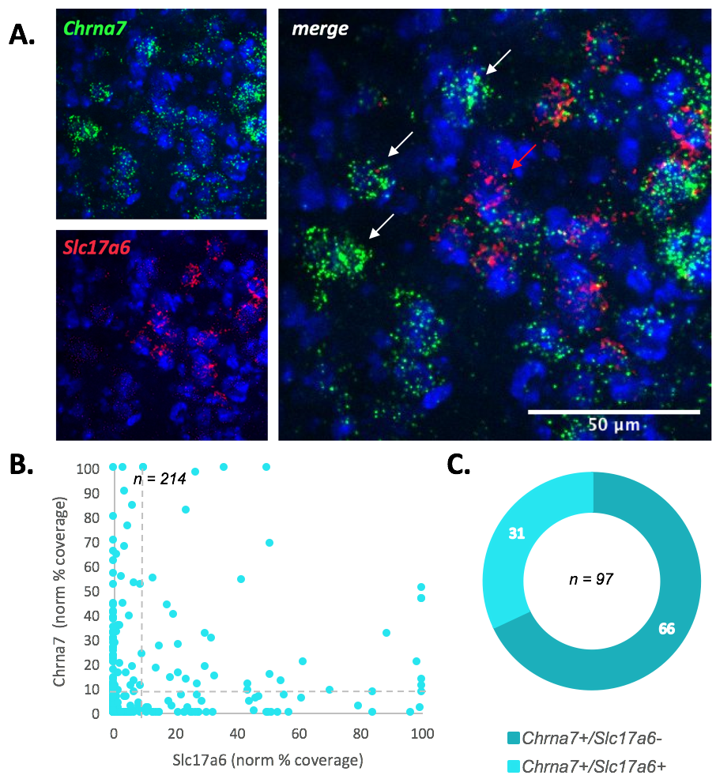
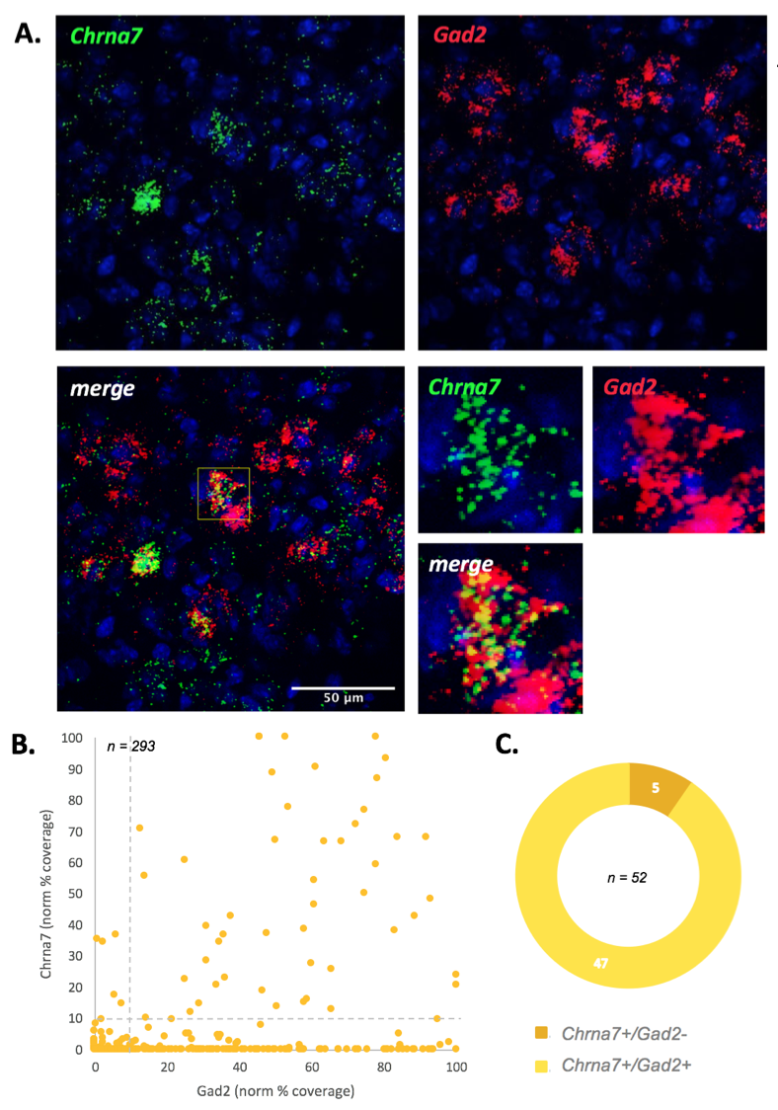
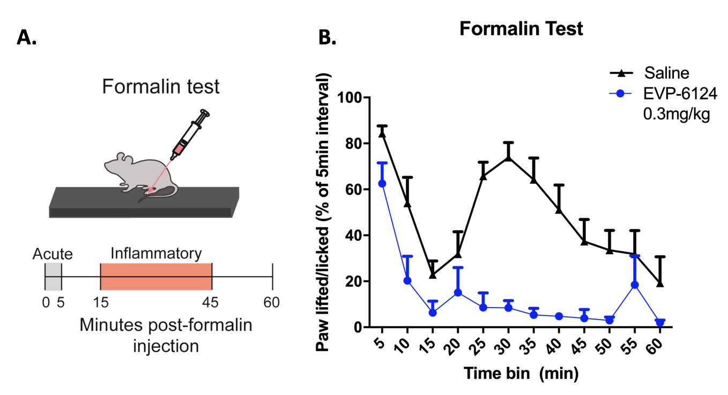
α7-nAChR agonist activation results in decreased nocifensive behavior. Previously published data from the McGehee lab showed that agonist-induced α7-nAChR activation produced anti-nociception in a rat formalin test. To verify this effect in mice, we conducted a formalin test in wildtype animals (Figure 1A). Animals were injected with 1: saline (i.p.) + 5% formalin (intraplanar) (pain condition), or 2: highly selective α7-nAChR agonist EVP-6124 (i.p.) + 5% formalin (intraplanar) (anti-nociceptive condition). Nocifensive behaviors were recorded over the following 60 minutes for each animal (Figure 1B). Heightened nocifensive behavior in the pain condition indicated two phases of formalin-induced pain perception: an acute phase 1 (0-5 mins post-injection) and a tonic inflammatory phase 2 (15-45 mins post-injection). As expected, activation of α7-nAChRs by EVP-6124 reduced nocifensive behaviors in response to formalin. Notably, induced anti-nociception was more pronounced in the tonic inflammatory phase of the test and less pronounced in the acute phase, consistent with previous rat data. These observations suggest that agonist activation of α7-nAChRs is inhibiting pain perception and creating anti-nociception.
Figure 3: Expression of α7-nAChR and glutamatergic cell markers in vlPAG. A. mRNA FISH images of vlPAG for probes of α7-nAChR (Chrna7) and vGluT2 (Slc17a6). White arrows indicate α7-nAChR+ cells and red arrows indicate vGluT2+ cells. B. Scatter plot of Slc17a6 (abscissa) versus Chrna7 (ordinate) normalized fluorescence coverage percentage for all FISH nuclei. Dashed line indicates the threshold values on each axis. C. Pie graph of α7-nAChR+ (Chrna7+) neurons showing fractions of Slc17a6+ and Slc17a6- nuclei.
Figure 4: Co-expression of α7-nAChRs and GABA cell markers in vlPAG. A. mRNA FISH images of vlPAG neurons for probes of α7-nAChR (Chrna7) and Gad2. A representative Chrna7+/Gad2+ cell is highlighted in the bottom right images. B. Scatter plot of Gad2 (abscissa) versus Chrna7 (ordinate) normalized fluorescent coverage percentage for all FISH nuclei. Dashed line indicates threshold values for each axis. C. Pie graph of α7-nAChR expressing (Chrna7+) neurons showing fractions of Gad2+ and Gad2- nuclei.
Figure 1: Formalin Test. A. Schematic of experimental design of formalin test.⁵ Injections of 5% formalin (10µL) were administered at time 0. Systemic saline or EVP-6124 (0.3mg/kg) was administered 15 mins prior. B. Graph of animal behavior during test. Time spent exhibiting nocifensive behaviors as a percentage of 5 min intervals over 60 minutes was recorded.
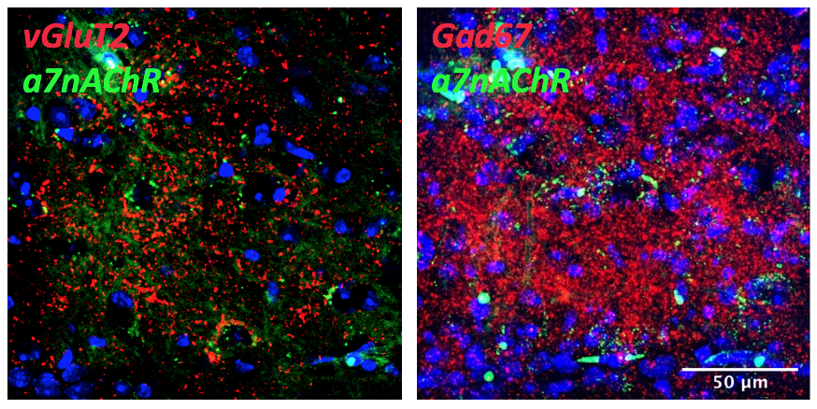
α7-nAChR expression shows preferential overlap with GABAergic neuron markers in vlPAG. To investigate the role of α7-nAChRs in producing anti-nociception, we wanted to identify the neuronal cell types the receptors were expressed on in vlPAG. α7-nAChR-expressing neurons were labeled using the highly selective neurotoxin αBGT conjugated to a fluorescent probe. Glutamatergic and GABAergic neurons were identified via antibody staining for the vesicular transporter, vGluT2, and synthetic enzyme, Gad67, respectively. Visual analysis revealed more overlap of α7-nAChRs with GABAergic markers than glutamatergic markers (Figure 2). However, the proteins for vGluT2 and Gad67 are often expressed in axonal compartments as well as cell soma, resulting in diffuse expression that decreases their identification in protein labeling experiments. This lack of specificity means that observed overlaps in fluorescence could be protein expression on the same vlPAG cell, on different, but overlapping vlPAG cells, or on the same or overlapping presynaptic inputs to vlPAG neurons.
Figure 2: Protein expression in vlPAG. Representative fluorescent images of vGluT2 (red, left) or Gad67 (red, right) protein co-expression with α7-nAChRs (green).

To overcome low signal to noise and poor cellular resolution of fluorescent probing of proteins, we used an amplified staining method for mRNA, RNAScope FISH, to further investigate overlapping expression patterns. As mRNA for glutamatergic and GABAergic markers are highly expressed in cell soma, mRNA labeling provides more accurate staining. Glutamatergic probes labeled mRNA for a vesicular transporter for glutamate (Slc17a6), GABAergic probes labeled mRNA for a synthetic enzyme for GABA (Gad2), and α7-nAChR probes labeled mRNA for an associated gene (Chrna7). The “normalized fluorescence coverage percentage” method of analysis was used for quantification as described in the Methods section. 30% of α7-nAChR+ cells also expressed mRNA for the glutamate transporter vGluT2 (Figure 3C). GABAergic FISH staining showed a much higher level of co-expression, where over 90% of α7-nAChR+ cells also expressed mRNA for the GABA enzyme Gad2 (Figure 4C). Both fluorescent protein staining and mRNA labeling showed remarkable overlap between markers of α7-nAChRs and markers of GABAergic neurons.
Figure 4: Co-expression of α7-nAChRs and GABA cell markers in vlPAG. A. mRNA FISH images of vlPAG neurons for probes of α7-nAChR (Chrna7) and Gad2. A representative Chrna7+/Gad2+ cell is highlighted in the bottom right images. B. Scatter plot of Gad2 (abscissa) versus Chrna7 (ordinate) normalized fluorescence coverage percentage for all FISH nuclei. The dashed line indicates the threshold values for each axis. C. Pie graph of α7-nAChR+ (Chrna7+) neurons showing fractions of Gad2 expressing (Gad2+) and non-expressing (Gad2-) nuclei.
Figure 6: C-fos levels in α7-nAChR-expressing cells in a control (top) vs. pain (bottom) condition. A. Representative IHC images of C-fos and α7-nAChR following in vivo administration of saline (top) or formalin (bottom). B. Scatter plots of C-fos (abscissa) versus α7-nAChR (ordinate) normalized percentage of coverage for all nuclei in vlPAG in the control (top) and pain (bottom) conditions. The dashed line indicates the threshold values for each axis. C. Pie graphs of α7-nAChR+ neurons showing fractions of C-fos+ and C-fos- nuclei in the control (top) and pain (bottom) conditions.
α7-nAChR expression overlaps with mu-opioid receptors in vlPAG. Previous work from the McGehee lab reported that α7-nAChRs and MORs were expressed on different neuronal populations in rat vlPAG. That conclusion was drawn from electrophysiological methods that may have underestimated MOR expression due to small responses and slow kinetics.³ We revisited this question of overlap using fluorescent protein labeling and FISH.
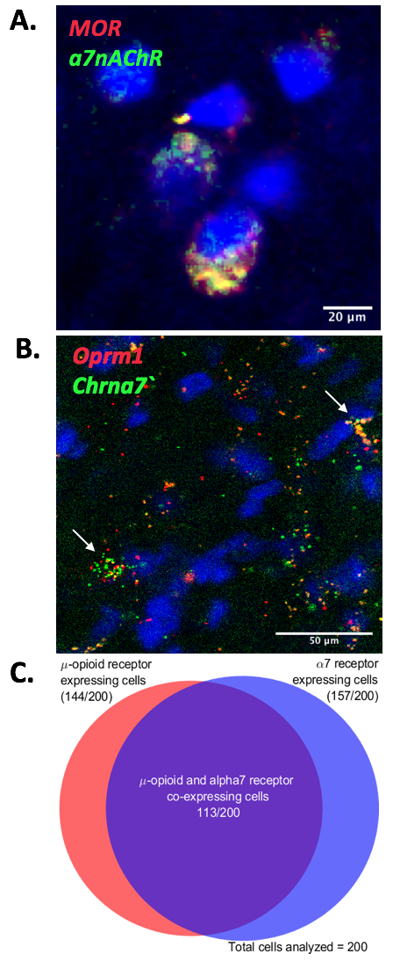
Fluorescent labeling suggested a high degree of overlap in expression of α7-nAChR MORs in vlPAG (Figure 5A). mRNA FISH labeling confirmed this surprising result (Figure 5B) and visual analysis quantified 57% of cells as showing co-expression of α7-nAChRs and MORs (Figure 5C). MORs are known to be highly expressed on GABAergic neurons in the vlPAG, making co-expression consistent with the observations in Figures 2-5 overall.
Figure 5: Co-expression of α7-nAChRs and MORs in vlPAG. A. Representative fluorescent labeling of α7-nAChRs (green) and MORs (red) showing co-expression (yellow) in vlPAG. B. Representative mRNA FISH labeling of vlPAG neurons for probes of α7-nAChR (Chrna7) and MOR (Oprm1). White arrows indicate neurons exhibiting co-expression. C. Venn diagram of mRNA FISH data quantifying vlPAG cells expressing α7-nAChRs (Chrna7), MORs (Oprm1), or both.
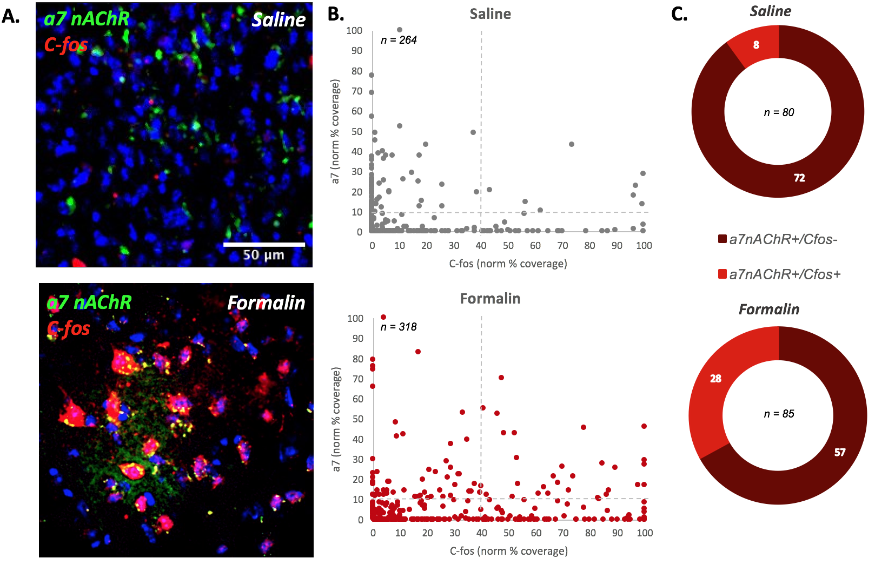
α7-nAChR-expressing cells become active in a nociceptive state. To explore the influence of pain on the activity of α7-expressing vlPAG neurons, a formalin test was conducted on wildtype animals, followed immediately by fluorescent labeling for expression of α7-nAChRs and c-fos. Animals were injected with 1: saline (i.p.) + saline (intraplanar) (control condition) or 2: saline (i.p.) + 5% formalin (intraplanar) (pain condition). Afterwards mice were trans-cardially perfused and tissue was assessed via fluorescent labeling for expression of α7-nAChRs and c-fos. Fluorescence from labeling was measured using the “normalized fluorescence coverage percentage” method. α7-nAChR-expressing cells showed significantly greater c-fos staining after administration of the chronically painful formalin stimulus (Figures 6A and B). Only 10% of α7-nAChR+ cells showed elevated c-fos levels in the saline condition compared to 33% of α7-nAChR+ cells in the pain condition (Figure 6C). Elevated c-fos levels suggests that α7-nAChR+ neurons respond to painful stimuli with increased neuronal activity, raising questions about the physiological effects of α7-nAChR activation in these neurons.
- CONCLUSIONS AND FUTURE DIRECTIONS
This study was concerned with the role of α7-nAChRs in producing anti-nociception in vlPAG. We confirmed that activation of α7-nAChRs via a systemically administered agonist produces anti-nociception in mice. To explore the cellular basis for this behavior, we characterized expression and activity patterns of α7-nAChRs. Labeling experiments found that α7-nAChR+ cells were predominantly GABAergic (90% of α7+ cells) and only subsidiarily glutamatergic (30% of α7+ cells). We also found a high degree of overlapping expression between α7-nAChRs and MORs. This suggests that activation of α7-nAChRs might produce anti-nociception indirectly via GABAergic interneurons in a similar manner as MOR-mediated analgesia. The GABA disinhibition hypothesis suggests that GABAergic cells are tonically activated in a pain state and when suppressed allow for the disinhibition of the analgesic pathway, resulting in anti-nociception. To assess how α7-nAChRs might affect GABAergic transmission, we conducted a formalin test and found that, as predicted, α7 neurons have elevated c-fos levels in response to pain.
In future experiments, we will conduct a formalin test on Chrna7-Cre animals virally infected with AAV9-DIO-EGFP in vlPAG and AAVrg-mCherry in RVM and measure c-fos expression in labeled α7-neurons in an anti-nociceptive condition. In accordance with the GABA disinhibition hypothesis, we expect to see decreased levels of c-fos in α7-expressing neurons and increased c-fos levels on labeled vlPAG-RVM projection neurons. This would suggest that activation of α7-nAChRs results in the suppression of activity of GABAergic neurons to produce anti-nociception.
Together, our data suggest that α7-nAChRs are expressed on GABAergic interneurons in the vlPAG and, unlike previously thought, are co-expressed with MORs on interneurons with a high degree of overlap. Furthermore, we suggest that α7-nAChRs contribute to pain information transmission in line with the GABA disinhibition hypothesis through stimulation of GABAergic neurons to create pro-nociception and suppression of GABAergic transmission to produce anti-nociception. Future experiments are needed to deepen our understanding of α7-nAChRs’ role in producing anti-nociception The continued search for alternatives to opioids requires further investigations into the modulation of the descending pain pathway.

- REFERENCES
[1] Lau, B. K., & Vaughan, C. W. (2014). Descending modulation of pain: the GABA disinhibition hypothesis of analgesia. Current Opinion in Neurobiology, 29, 159–164. doi: 10.1016/j.conb.2014.07.010
[2] Samineni, V. K., Grajales-Reyes, J. G., et al., (2017). Divergent Modulation of Nociception by Glutamatergic and GABAergic Neuronal Subpopulations in the Periaqueductal Gray. Eneuro, 4(2). doi: 10.1523/eneuro.0129-16.2017
[3] Umana, I. C., Daniele, C. A., et al., (2017). Nicotinic modulation of descending pain control circuitry. Pain, 158(10), 1938–1950. doi: 10.1097/j.pain.0000000000000993
[4] Yan, Y., Beckley, N. A., et al., (2019). Differential Nicotinic Modulation of Glutamatergic and GABAergic VTA Microcircuits. Eneuro, 6(6). doi: 10.1523/eneuro.0298-19.2019
Figure 6: C-fos levels in α7-nAChR-expressing cells in a control (top) vs. pain (bottom) condition. A. Representative IHC images of C-fos and α7-nAChR following in vivo administration of saline (top) or formalin (bottom). B. Scatter plots of C-fos (abscissa) versus α7-nAChR (ordinate) normalized percentage of coverage for all nuclei in vlPAG in the control (top) and pain (bottom) conditions. The dashed line indicates the threshold values for each axis. C. Pie graphs of α7-nAChR+ neurons showing fractions of C-fos+ and C-fos- nuclei in the control (top) and pain (bottom) conditions.

[5] Alhadeff, A. L., Su, Z., et al., (2018). A Neural Circuit for the Suppression of Pain by a Competing Need State. Cell, 173(1). doi: 10.1016/j.cell.2018.02.057

