Development of the Early Neural Tube During Chick Embryogenesis
Anne Havlikª and *Timothy Sanders, MD, PhD^{a,b}
a: Grossman Institute of Neuroscience, University of Chicago, Chicago, IL, 60637
b: Department of Pediatrics, University of Chicago, Chicago, IL, 60637
ahavlik@uchicago.edu
tasanders@uchicago.edu

Abstract - In partnership with Dr. Timothy Sanders, MD, PhD, this study sought to further reveal the unknown mechanisms of neural tube closure in vertebrate embryos. As the neural tube develops, an array of complex morphogenetic movements leads to changes in cell morphology and cell fate. These changes result in epithelial fusion of opposing specialized structures known as neural folds, leading to the creation of two separate structures: the neural tube and the non-neural ectoderm. The communication between neural progenitor cells was studied through both fixed and live embryo imaging of stained membranes in the chicken embryo, a widely accepted model organism in developmental biology. Through fixed embryo staining and live embryo injection of targeted membrane specific dyes followed by electroporation, pathways of injected progenitor cells were imaged during early stages of embryonic development. The authors used bright-field microscopy, stereomicroscopy fluorescence, and computational clearing, paired with the use of several different dyes and trials to mechanistically image and delineate cellular architecture of the process of neural tube closure in chick development. The authors created a reliable experimental paradigm to collect and image the morphology of the closing neural tube in developing chick embryos. The researchers created this convenient developmental tool via exploration and optimization of several combined methods to further delineate the process of neural tube closure both anteriorly and posteriorly throughout early vertebrate nervous system development. This information is useful for furthering our understanding of one of the most common birth defects in humans, neural tube defects (NTDs). NTDs, posteriorly identified as spina bifida, affect the human nervous system functions in over 300,000 live births per year. This experimental paradigm will allow us to advance our understanding of NTDs as well as improve treatment strategies for patients with NTDs.

Introduction
This study explored the mechanism of early nervous system development via neural tube closure in chick embryos. Neural tube closure during embryogenesis is a developmental process that has not been clearly elucidated thus far. The proposed and widely accepted mechanism of neural tube closure is that cells communicate changes in morphology and lineage which initiate morphogenetic movements such as the convergence of neural folds. These complex morphogenetic movements result in epithelial fusion of opposing neural folds that separates the neural tube from non-neural ectoderm. This step of neurulation is the least understood of neural tube formation.
During embryonic development, the outer layer covering the late stage gastrula, ectoderm, has great developmental significance. The dorsal portion of the vertebrate ectoderm will become the neural plate. The neural plate involutes into the body while cavitating to create the neural tube. The neural tube is a precursor to the central nervous system, the brain and the spinal column.² Between the compartments forming the epidermis and the CNS, there is neural crest. The neural crest cells migrate away from the dorsal center of the embryo to form the peripheral nervous system in vertebrates.²
Two major movements, primary neurulation and secondary neurulation, move the neural plate cells morphologically into creation of the neural tube. Primary neurulation is largely similar in all vertebrates.² The neural crest is a transient structure in which cells undergo epithelial-mesenchymal transition to disperse throughout the body. Therefore, there is a very brief developmental opportunity to observe the neural tube formation in a developing embryo.
The chick embryo is the preferred organism to study neural tube closure in comparison with other developmental models given its early planar development properties and its great accessibility. Early chick embryological development is also a useful model for studying human development comparatively to tailed amniotes, which is useful to further the understanding of neural tube defects (NTDs) that affect human nervous system function. NTDs are one of the most prevalent congenital malformations, affecting 1 out of every 1,000 live births.¹ In the posterior of the neural tube, NTDs are collectively referred to as spina bifida. In the anterior of the neural tube, NTDs can result in embryologically terminal complications, such as anencephaly.

Methods

Chemical Fixation to Preserve Macroscopic and Microscopic Structure and Staining of Embryos
The first method the authors utilized to delineate the process of neural tube closure during vertebrate embryogenesis was staining fixed embryos using DNA and membrane specific dyes. The embryos used in this study were harvested from Hamburger Hamilton stages 5-10, where the chicken eggs were incubated at 37° C for 24-36 hours in an orientation where the large base was horizontal to the floor of the incubator.³ This orientation allowed for staining of a wide variety of developmental processes and structures, from the early notochord to 16 somite formation with presence of telencephalon, diencephalon, metencephalon, telencephalon and the spinal cord. Embryos were initially harvested in ovo. Incubating eggs were removed from the incubation chamber at the scheduled incubation end time depending on the preferred Hamburger Hamilton stage of collection. The eggs were acclimated to room temperature for one hour prior to manipulation. They were then windowed using the Korn and Cramer technique.⁴ This windowing allowed a small working space above the embryo inside the egg shell. This working space allowed the researchers to make small, superficial cuts with embryologic scissors surrounding the area pellucida of the embryo to ensure that the entire embryo was collected with some developing vasculature. The embryos were also collected utilizing Yukinori’s whole-embryo culture technique/ “Basic Protocol 1.”⁹ This allowed for an ex ovo filter paper artificial support system for the embryos to prevent enfolding during fixation.
Following embryo collection, the embryos were washed gently to remove as much yolk as possible with a small stream of room temperature physiologic saline from a transfer pipette. Utilizing a modified P1000 pipette tip that was cut, embryos were then preincubated in a buffer system by rinsing the embryos at 4° C PHEM with 2% sucrose and then allowed to settle for 2-5 minutes. After preincubation, the embryos were chemically fixed in a PHEM-sucrose-paraformaldehyde-glutaraldehyde solution calibrated to preserve macroscopic and microscopic structure in the embryos for one hour at 4° C. This soft fixation allowed for the intricate structures and cellular projections of neural tube closure to be preserved. Following fixation, the embryos underwent several post-fixation washes at 4° C with a PHEM-sucrose-glutaraldehyde solution. Embryos were transferred with a cut P1000 pipette tip into two quick rinses of the post-fixation wash, and then into three longer ten minute washes to remove any remaining fixative. The embryos were then transferred to PBS or phosphate buffer to be stained. Embryos that had been collected with Yukinori’s technique were microdissected following fixation in order to remove the artificial filter paper support matrix prior to staining.
The embryos were stained with a mixture of primarily four different post-fixation stains, with slightly changed protocols from the manufacturer (Biotium). The protocols were changed to accomodate staining the entire embryo, as the protocols were created to instead stain only a few cells. The first stain used was MitoView Green, a fluorescent mitochondrial stain. The manufacturer protocol was followed, with modification of the initial reconstitution volume. The dye was reconstituted from 300 uL instead of 400 uL DMSO.⁵ This exchange was made to create a higher concentration of the dye for staining a whole embryo, versus the manufacturer’s reconstitution volume based on staining a smaller number of cells. CF 568 Wheat Germ Agglutinin (WGA) Conjugate was used to visualize the cell boundaries and morphologies of neural tube closure via labeling the plasma membrane (see figure 1b). The lectins labeled glycoproteins on the surface of the embryos. The manufacturer's protocol was changed to allow a much longer one hour stain incubation period for the embryos, completed at room temperature instead of 37 °C.⁶ Following WGA staining, cells were stained with the DNA dye DAPI. DAPI was used to visualize the nucleus of the cells during neural tube closure. Biotium’s protocol for fixed cells was utilized to successfully implement the nuclear counterstain in the embryos.⁷ Finally, embryos were permeabilized and actin filaments were stained with Phalloidin Conjugates (CF 488 A). Again, the manufacturer's protocol was followed, with modification to the concentration of fluorescent phalloidin stock solution. The stock solution concentration was increased to 7.5 uL per 200 uL PBS and the incubation period of embryos in the stain was raised to one hour.⁸. The phalloidin stain was used to visualize the cytoskeleton and F-actin throughout neural tube closure, shown in Figure 1a.
Following staining, the embryos were flat mounted and imaged using a variety of techniques. All embryos were imaged using stereomicroscopy fluorescence and bright-field microscopy, while embryos with unclosed posterior neural tubes were imaged and computationally cleared using Leica’s THUNDER imaging system.

Electroporation of Live Embryos
Another approach the researchers used to visualize the mechanisms of neural tube closure was electroporation of live embryos. The embryos were incubated for ~28 hours to achieve Hamburger Hamilton stage 7-8.³. Following protocol established in “Chick Embryo Culture and Electroporation,” whole embryos were again cultured on artificial filter paper support matrices and “Basic Protocol 2” was followed to electroporate mScarlet, a targeted membrane into the mid regions of the neural tube.⁹ Embryos were then placed into a submerged filter paper sandwich and placed into a large petri dish of water to control exposure to humidity. This process involved adapting Yukomori’s technique with Schmitz’s in “A Submerged Filter Paper Sandwich for Long-term Ex Ovo Time-lapse Imaging of Early Chick Embryos.”¹⁰ The setup for this devised ‘Frankenstinian’ process with heavy adaptations from Yukomori and Schmitz can be seen in Figure 2. Using this setup, the researchers followed expression of the mScarlet transgene in injected cells via stereo microscopy fluorescence tracing for several days into the subsequent development of the embryos.

Results & DISCUSSION
The researchers found that the labeling of cellular components via both methods discussed above was very helpful in delineating the complex morphogenetic processes of neural tube closure in vertebrates. In this study the authors created a replicable and reliable experimental paradigm to image the developing embryo morphology and the cell fates of neural tube closure in chicken embryos. This project devised a convenient developmental tool via optimization of several previously established methods to further delineate the process of neural tube closure both anteriorly and posteriorly throughout early nervous system development. Bright-field light and fluorescence microscopy paired with the use of several different DNA membrane specific dyes and trials allowed for the mechanistic imaging and delineation of the cellular architecture of neural tube closure. Electroporation in live embryos along with optimization of the aforementioned developmental tools allowed for labeling and tracking of a small neural tube region during development, as shown in Figure 3. This small regional neural tube labeling allowed for sparse imaging to delineate neural tube closure at different Hamburger Hamilton stages in both the anterior and posterior regions of the embryonic neural tube.

Tables and Figures
Figure 1a: example of phalloidin staining in fixed embryo, posterior neural tube open
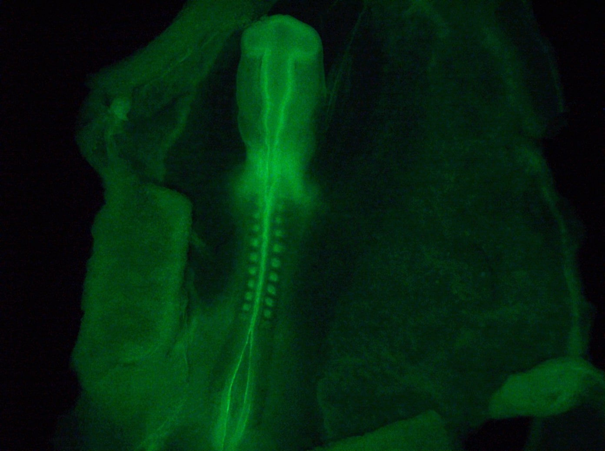
Figure 1b: example of WGA staining in fixed embryo, anterior neural tube partially open, posterior neural tube open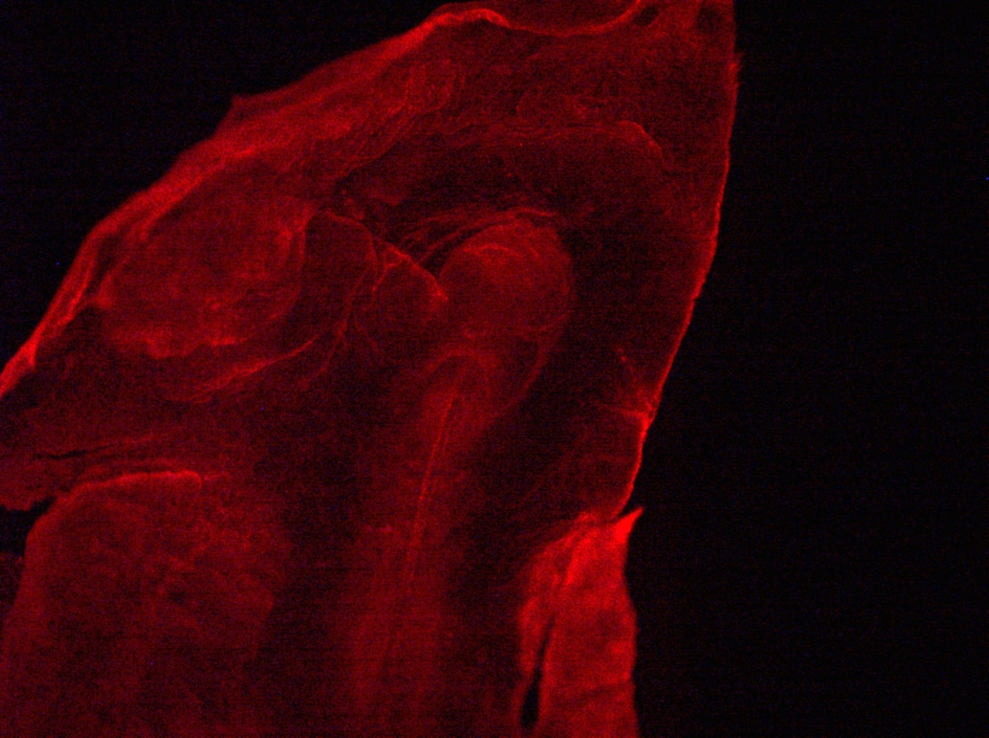
Figure 2: adapted ‘Frankenstinian’ method of electroporated embryo
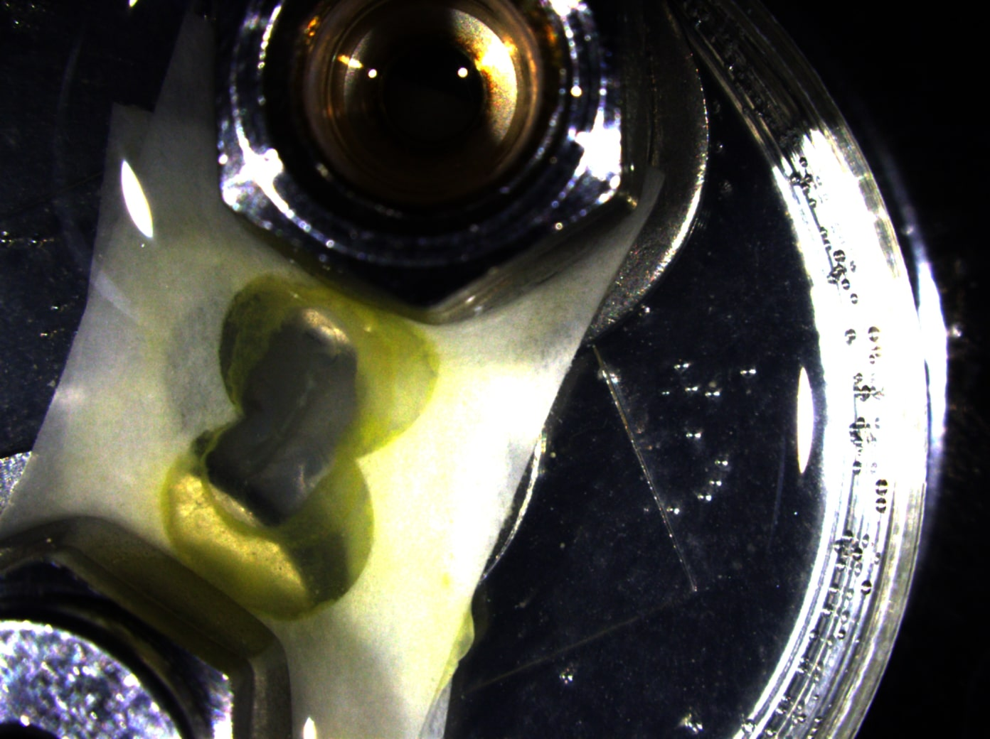
Figure 3: sparse mScarlet expression in live, electroporated developmental day 3 embryo in the mid region of neural tube
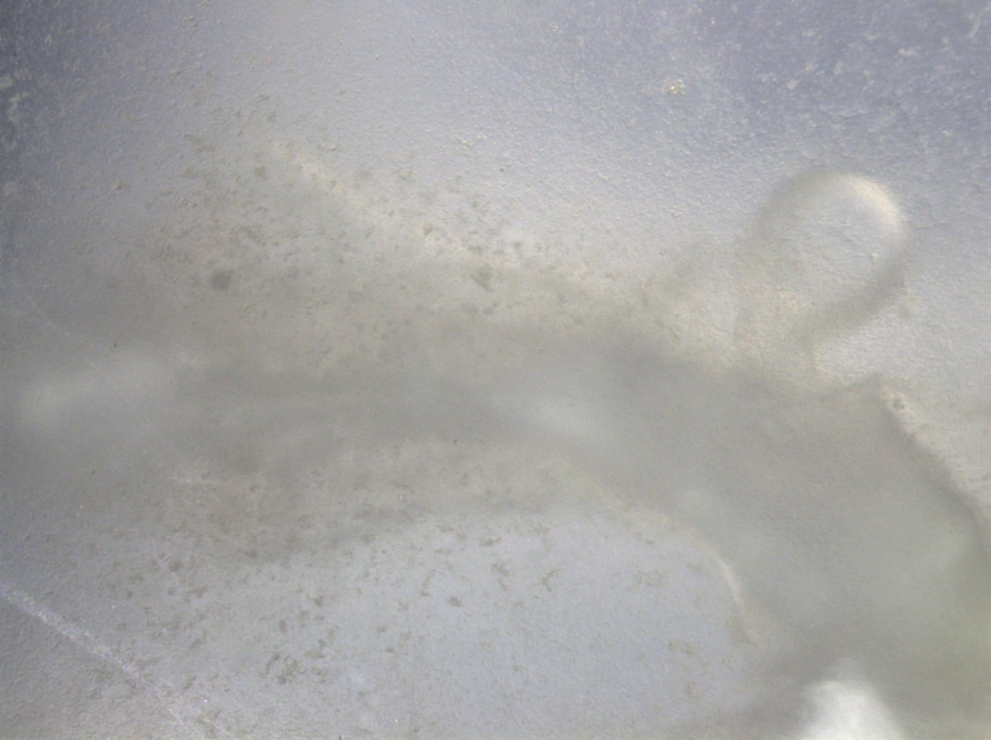
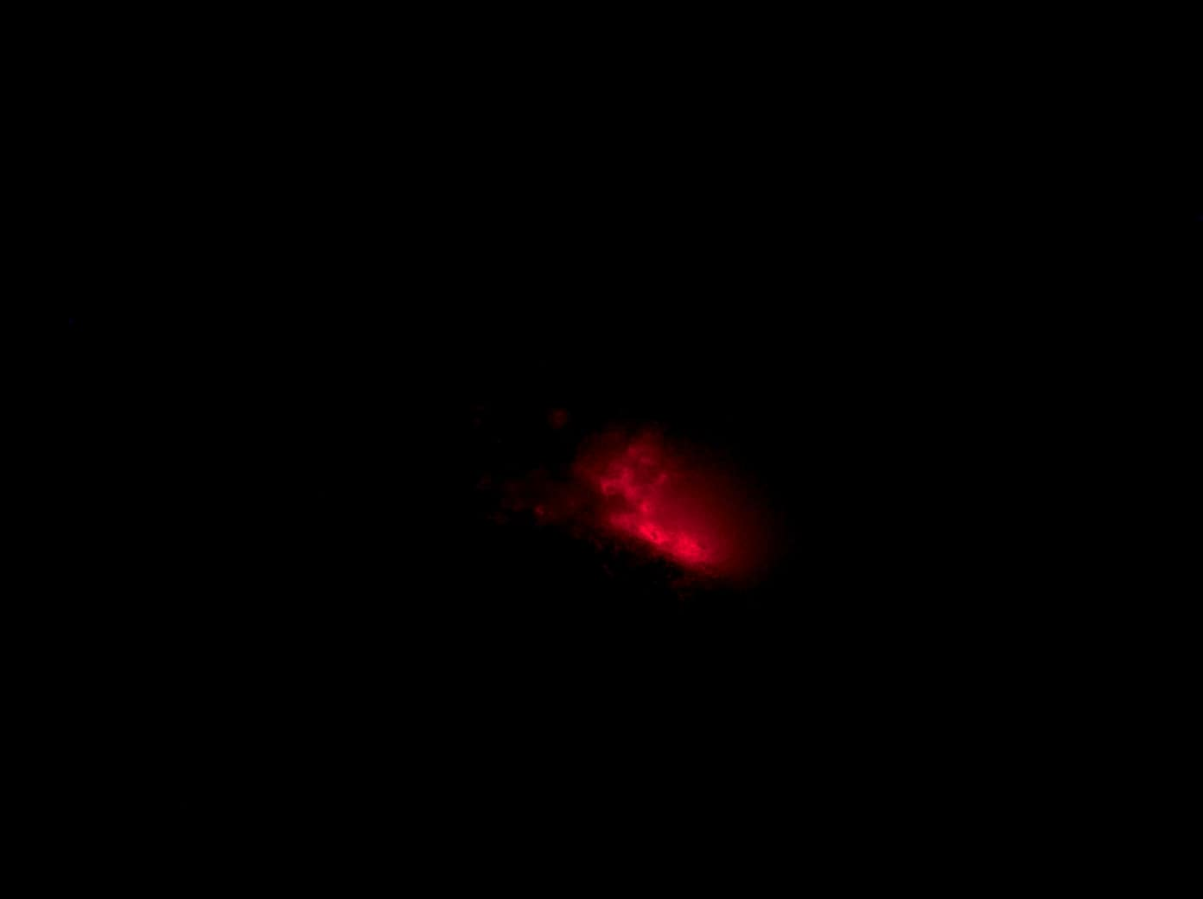

Conclusion
The authors examined the morphogenetic cellular mechanisms of neural tube closure through techniques of chemical fixation to preserve macroscopic and microscopic structure and staining as well as electroporation of live embryos. Through chemical fixation to preserve macroscopic and microscopic structure followed by a variety of staining the embryos, the researchers were able to broadly image the morphogenetic changes leading up to, during, and after neural tube closure. However, with too many components labeled at once, the image tended to be overcrowded with fluorescent noise and distinguishing one cellular component from the next proved difficult. Thus, the researchers then used a more specific approach of dye injection followed by electroporation and tracking of the mScarlet transgene over early development in live embryos. This technique allowed for more sparse labeling of neural tube closure. By having more modest labeling, the authors were able to hone in on the specific cellular architecture of the morphogenetic changes during neural tube closure. Subsequent experiments should explore further the techniques of electroporation to create a mosaic of the developing neural tube for imaging at similar stages. Additionally, imaging of the initially fixed and stained embryos via scanning electron microscopy would give finer detail into the surface topography of the developing embryo. This would be helpful to image tubulin-based projections such as tunneling nanotubes or special filopodia extending from the neural crest plates and opposing sides of the neural fold. Furthermore, the electroporation techniques devised and adapted in this project are currently being used in further experimentation to explore notochord development and signaling in the very early embryo in the Sanders lab.

References
- Neural Tube Defects (NTDs) | Duke Molecular Physiology (n.d.). Retrieved May 1, 2020, from https://dmpi.duke.edu/neural-tube-defects-ntds
- Wolpert, L., Tickle, C., Arias, A. M., Lawrence, P. A., &amp; Locke, J. (2019). Principles of Development. Oxford (UK): Oxford University Press.
- Hamburger Hamilton Stages - Embryology. (n.d.). Retrieved May 1, 2020, from https://embryology.med.unsw.edu.au/embryology/index.php/Hamburger_Hamilton_Stages
- Korn, M. J., & Cramer, K. S. (2007). Windowing chicken eggs for developmental studies. Journal of visualized experiments : JoVE, (8), 306. https://doi.org/10.3791/306
- MitoView™ Mitochondrial Dyes | Biotium. (n.d.). Retrieved May 1, 2020, from https://biotium.com/product/mitoview-dyes/
- Wheat Germ Agglutinin (WGA) Conjugates. (n.d.). Retrieved May 1, 2020, from https://biotium.com/product/wheat-germ-agglutinin-wga-cf-dye-conjugates/?attribute_pa_size=1-mg&amp;attribute_pa_conjugation=cf568
- DAPI | Biotium. (n.d.). Retrieved May 1, 2020, from https://biotium.com/product/dapi/
- Phalloidin Conjugates | Biotium. (n.d.). Retrieved May 1, 2020, from https://biotium.com/product/phalloidin-conjugate/
- Endo, Y. (2012), Chick Embryo Culture and Electroporation. Current Protocols in Cell Biology, 56: 19.15.1-19.15.10. doi:10.1002/0471143030.cb1915s56
- Schmitz, M., Nelemans, B. K., & Smit, T. H. (2016). A Submerged Filter Paper Sandwich for Long-term Ex Ovo Time-lapse Imaging of Early Chick Embryos. Journal of visualized experiments : JoVE, (118), 54636. https://doi.org/10.3791/54636

